1. Create a class cal1 that will calculate sum of three numbers. Create setdata() method which has three parameters that contain numbers. Create display() method that will calculate sum and display sum.

class MyClass:

n1=0

n2=0

n3=0

def setdata(self,n1,n2,n3):

self.n1=n1

self.n2=n2

self.n3=n3

self.display()

def display(self):

ans = self.n1+ self.n2+ self.n3

print('n1+n2+n3=',ans)

c1=MyClass()

print('Enter 3 value')

n1=int(input())

n2=int(input())

n3=int(input())

c1.setdata(n1,n2,n3)

**OUTPUT:**

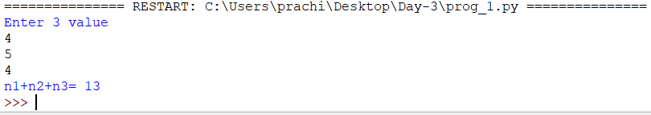

1. Create a class cal2 that will calculate area of a circle. Create setdata() method that should take radius from the user. Create area() method that will calculate area . Create display() method that will display area .

class cal2:

n1=0

def setdata(self):

print('Enter radius value')

self.n1=int(input())

self.area()

def area(self):

ans=3.14*(self.n1)*(self.n1)

self.display(ans)

def display(self,ans):

print('Area of circle is ',ans)

c1=cal2()

c1.setdata()

**OUTPUT:**

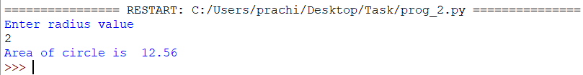

1. Create a class cal3 that will calculate simple interest. Create constructor method which has three parameters .Create calInterest() method that will calculate Interest . Create display() method that will display Interest.

class cal3:

p=0

r=0

t=0

def __init__(self):

print('Enter values of p,r,t(time in year)')

self.p=int(input())

self.r=float(input())

self.t=int(input())

def cllinterest(self):

i= (self.p*self.r*self.t)/100

self.display(i)

def display(self,ans):

print('Area of circle is ',ans)

c1=cal3()

c1.cllinterest()

**OUTPUT:**

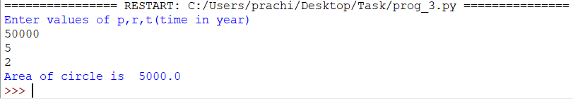

1. Create a class cal4 that will calculate square of a number. Create setdata() method which has one parameters that contain number. Create display() method that will calculate sum.(Function should return value)

class cal4:

n=0

def setdata(self,n):

self.n=n

ans=self.display()

print('Area of circle is ',ans)

def display(self):

ans= n*n

return ans

c1=cal4()

print('Enter value')

n=int(input())

c1.setdata(n)

**OUTPUT:**

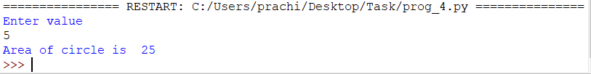

1. Consider an employee class, which contains fields such as name and designation. And a subclass, which contains a field salary. Write a program for inheriting this relation.

**OUTPUT:**

1. Create a class cal5 that will calculate area of a rectangle. Create constructor method which has two parameters .Create calArea() method that will calculate area of a rectangle. Create display() method that will display area of a rectangle.

**OUTPUT:**

1. Create a class cal6 that will calculate area of a square. Create setdata() method that should take length from the user. Create area() method that will calculate area . Create display() method that will display area

**OUTPUT:**

1. Write a program with use of inheritance: Define a class publisher that stores the name of the title. Derive two classes book and tape, which inherit publisher. Book class contains member data called page no and tape class contain time for playing. Define functions in the appropriate classes to get and print the details.

**OUTPUT:**

1. Create a class called scheme with scheme_id, scheme_name,outgoing_rate, and message_charge. Derive customer class form scheme and include cust_id, name and mobile_no data.Define necessary functions to read and display data.

**OUTPUT:**

1. Create a arith class. The class should have a parameterized constructor and methods to add, subtract and multiply two numbers and to return the answers.

**OUTPUT:**